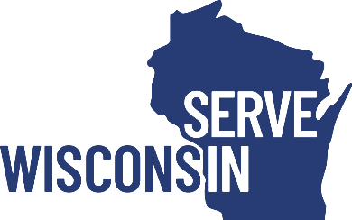
Attachment E

Alignment with Wisconsin State Service Plan

The purpose of this form is to determine the alignment that AmeriCorps State applicants have with the Wisconsin State Service Plan. Submission of this form by the deadline specified in the RFP is required.

Please review the Wisconsin State Service Plan at servewisconsin.wi.gov/state-service-plan and answer the questions below to the best of your ability. Some questions may not be applicable to new applicants. This form can be provided in alternate formats by contacting the RFP Manager at ServeWisconsin@Wisconsin.gov.

Please describe, where appropriate, how your organization/program aligns with the following objectives of the Wisconsin State Service Plan.

If the answer is part of your program design and included in the application narratives or Logic Model, please write “See application.” Our intent with this form is to learn about program details that might not be the main focus of your program.

- Facilitate the growth & development of strong AmeriCorps programs

- Develop Serve Wisconsin’s AmeriCorps VISTA program to serve BIPOC led organizations and alleviate poverty in Wisconsin

- Support AmeriCorps & AmeriCorps VISTA members from recruitment through alumni status

- Support Disaster Response & Preparedness in Wisconsin

- Support Volunteerism in Wisconsin

- Increase Service for Wisconsin citizens aged 55 and older, and people with disabilities

- Increase awareness of Serve Wisconsin, AmeriCorps, and National Service in Wisconsin

- Advocate nationally & locally with AmeriCorps and Elected Officials for policies and procedures that support AmeriCorps members and programs

- Increase the Capacity of Serve Wisconsin to allow for increased and sustainable investment in our communities

Yes | No
☐ | ☐ | My program will nominate worthy candidates for the Governor Service Awards.  The Governor Service Awards are given each spring to exemplary supporters of service in Wisconsin.
☐ | ☐ | My program utilizes (or will utilize) the Annual Member Survey results to inform program improvement.
☐ | ☐ | My organization is registered (or will register) on the Volunteer Wisconsin website.
Please mark Yes or No to the following statements.

